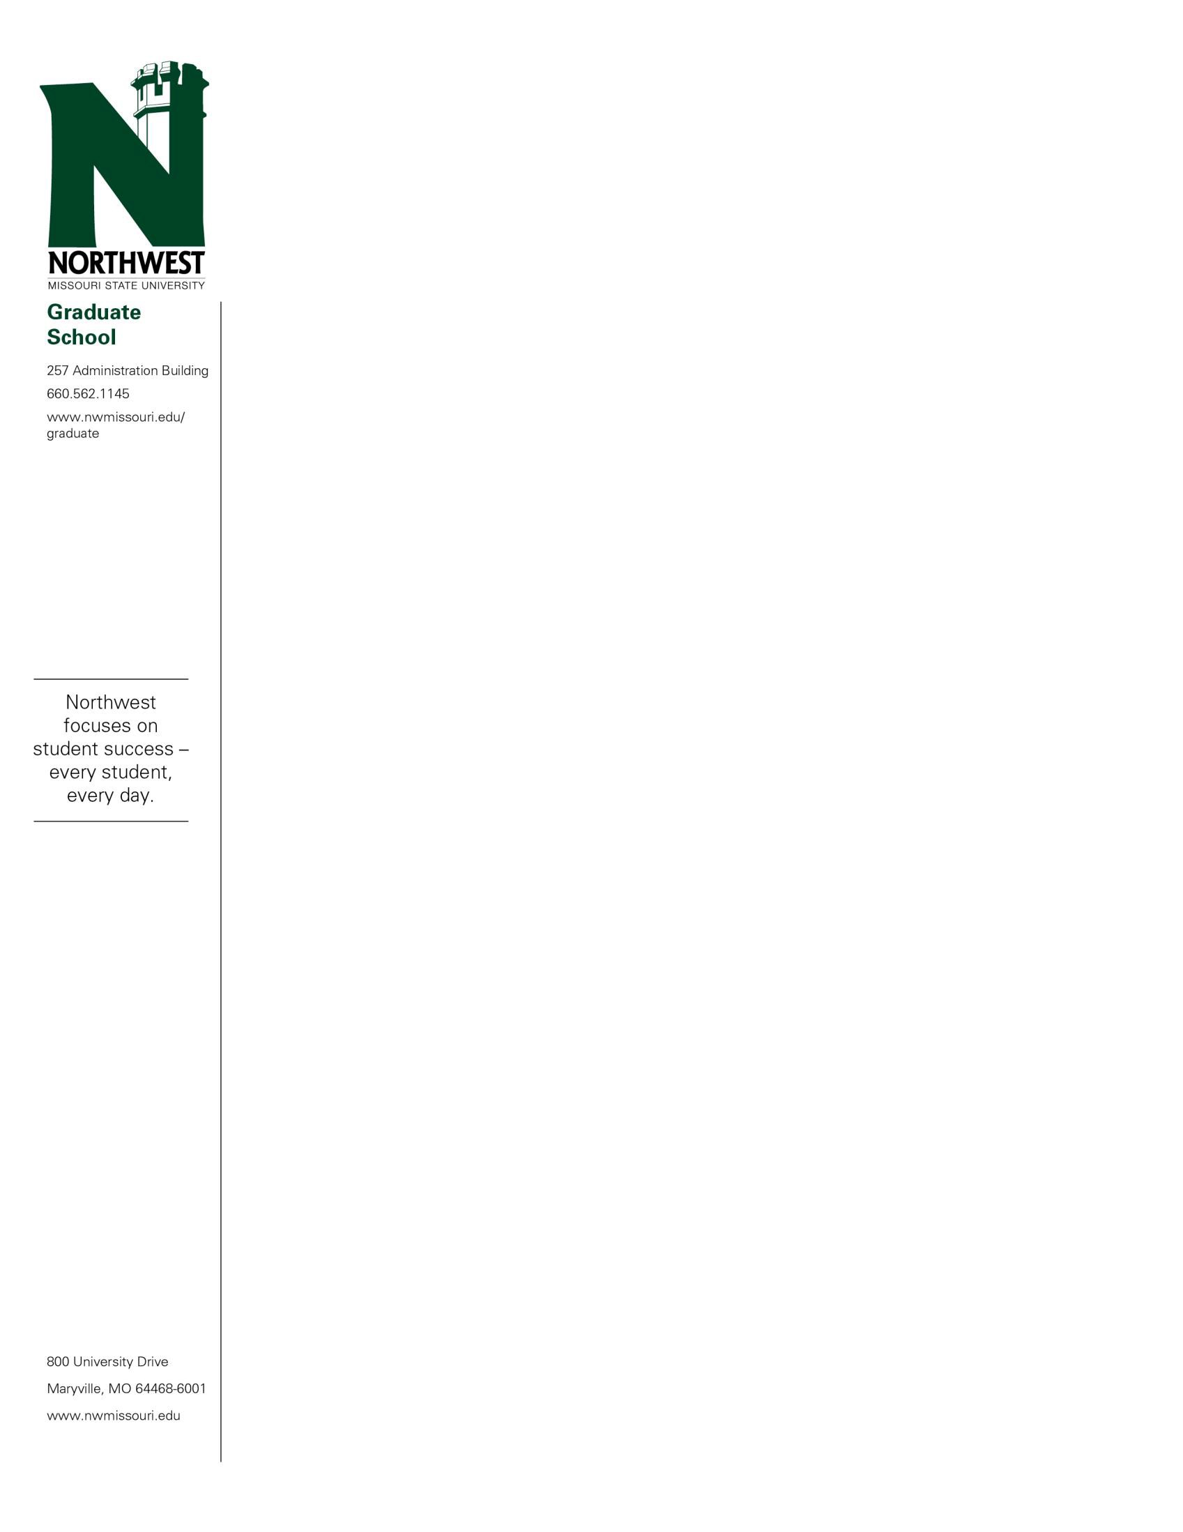

June 8, 2022

«FIRSTNAME» «LASTNAME»

«STREET»

«CITY», «STATE» «ZIP»

Dear «FIRSTNAME»:

Congratulations! You have been conditionally admitted into the Northwest Missouri State University Online Professional Master of Science: Data Analytics program beginning in the «TERM» semester. Full acceptance into the MS: Data Analytics program is pending compliance with the following admission policies:

Conditional Admission into the M.S. Data Analytics program states:

A minimum overall GPA of 2.75 is required. A student who has an undergraduate GPA below a 2.75 may be considered for full admission after he/she has completed eight hours of required graduate coursework at Northwest with a GPA of 3.00, or be subject to suspension for one calendar year. During this time, you will be restricted to registering in 3 credit hours per block.

«ADVISOR» serves as your academic advisor for the program. Her email is «ADVISOREMAIL».

Please review this letter carefully and contact the Graduate Office at 660- 562-1144 with any questions or concerns.

All coursework submitted to fulfill a master’s degree must be completed within an eight-year time period.

Northwest Missouri State University is proud of a long tradition of academic excellence, a fine faculty and a strong academic curriculum. We are happy for the opportunity to help you meet your educational goals.

Sincerely,



Gregory Haddock

Associate Provost of Graduate and Professional Studies